Reading 12- Lead EKGs 3 / 04

I’m not sure if updating these articles is such a good idea - they just get bigger and bigger, and we throw more and more stuff in, and they just get monstrous and probably scary for the new kids. It’s fun to a point – but we’re trying to convey the basics here, or at least what passes for the basics as we understand them. Well… let us know what you think. Too big? Too much? Or too full of mistakes? (grin!). The whole thing already prints out like the telephone book…

- What is an EKG?
- What is a 12-lead EKG?
- When you do an EKG, what are you looking for?
- What do EKG lead groups have to do with cardiac anatomy?
4-1: Inferior
4-2: Lateral
4-3: Anterior
4-4: Septal
- What is the difference between coronary ischemia and a myocardial infarction?
5-1: A brief rant.
- What does ischemia look like on a 12-lead?
6-1- What do I do if my patient is having ischemia? What is “flashing”?
- What are the stages of an MI, and what to they look like on a 12-lead EKG?
7-1- Acute Injury: ST elevations.
7-2- Necrosis: Q-waves.
7-3- Resolution: persistent Q-waves or flipped T’s.
7-4- What do I do if my patient is having an MI?
- What is reciprocity?
8-1- What is a right-ventricular MI, and why is it going in the section on reciprocity?
8-2- How are RVMIs managed?
- Going through the evolving EKGs of an MI.
9-1- Stage 1- the acute infarct.
9-2- Stage 2- necrosis.
9-3- Stage 3 - resolution
- Another one.
- What are intervals all about?
11-1- PR interval
11-2- QRS interval
11-3- QT interval
12- What does a 12-lead EKG look like if a patient’s potassium is too high? Too low?

A couple of words about confidence: EKG interpretation often gets classified a nurse’s mind as one of those things that he should just stay away from. I really think that this is just plain wrong. I think that any nurse who is smart enough to make it into an ICU in the first place is certainly smart enough to learn the basics of EKG interpretation: what the stages of an MI look like. What big ischemia and its resolution look like. And where in the heart it’s happening.

This does not mean that you are supposed to be able to tell the difference between a “neo-Stalinist pre-excitation syndrome”, and “variant Lown-Ganong-Beethoven-versus-Hootie-and-the-Blowfish, Type 2”. This is why the Great Nurse Manager in her wisdom created cardiologists, and am I ever glad she did, because I don’t want to stay up nights studying all that stuff.

But - now trust me on this - the basics are not that hard. And they really are an essential skill.

So let’s do it!

- What is an EKG?

Everybody remember that the heart works electrically? SA node, AV node, all that? The signal travelling along its normal pathway goes from roughly northwest to roughly south, uh…southeast?

This diagram shows the electrode placement for lead II, the “reference lead”, which follows the normal conduction pathway – unlike the other leads, which look at conduction from all sorts of other directions.

Northwest: negative electrode goes here
(the ground electrode goes here…)
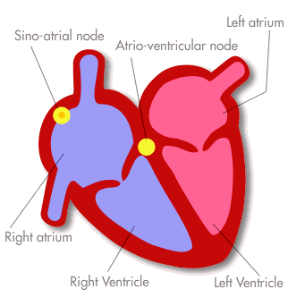

Southeast: Positive electrode here
www.arrhythmia.org/ general/whatis/

As the impulse goes along in lead II, it makes - or it ought to make – the normal conduction complex that we all learned, like so:

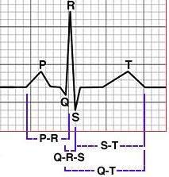
And everybody remembers what the different parts of the complex are: the PR interval represents the signal going through the atria, so it makes a small-sized wave? And the QRS represents the signal going through the what? So it makes a what-sized wave? And the T-wave represents the re-setting of what?

Right - no problems so far.

However, when bad things happen, things start to look a little different.

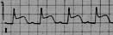
It might look like this:

(What is this? What’s
it called, I mean?)

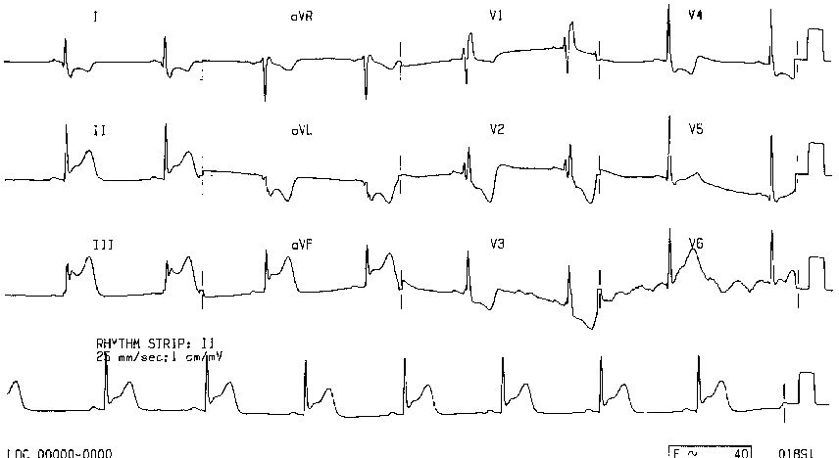
Or this:

(This?)

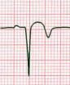
Or this:

(Doesn’t look
right, does it?)

First we need to look a little more at what a 12-lead EKG really does.

- What is a 12-lead EKG?

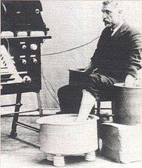

“Willem Einthoven! Are you sure there isn’t going to be any lightning tonight?”

http://home.t-online.de/home/Dr.Ursin.Bernd/Einthoven1.jpg

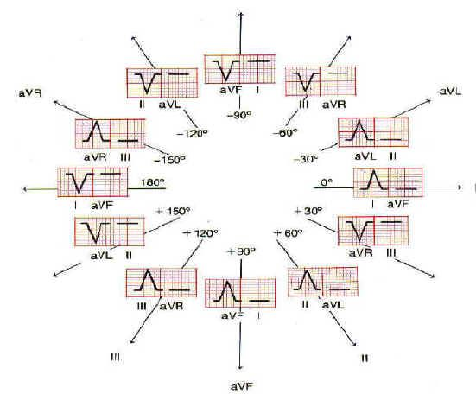

Even though the electical signal travels through the heart in only one direction, it can be looked at from any other direction that you want: upwards, from the feet. Downwards, from the head. Side to side, front to back - that’s what this diagram is telling us: it’s a matter of moving the monitor wires around, and looking from different vantage points.

http://www.medspain.com/curso_ekg/ekg5c.jpg

3- When you do an EKG, what are you looking for?

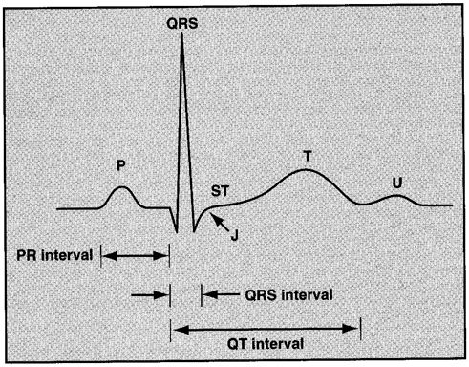
- Rhythm: you’re trying to figure out what rhythm the patient is in. Rhythms and arrhythmias have their own FAQ, so take a look over there for more on this subject.

- MI: you’re looking for changes in the normal complex -like this one on the left - that indicate one phase or another of an MI. ST elevations? Q-waves? This is where you look.

- Ischemia: you’re looking for changes in the normal complex that indicate the presence, or resolution of ischemia: ST depressions, or flipped T-waves…

- Intervals: you’re trying to figure out if the intervals are normal. Too long, too short? We’ll get into some of it.

- Changes associated with electrolyte problems: There are also a couple of waveform changes associated with electrolyte disturbances that you should get a look at – we’ll take a look at a couple of them as well…

http://www.clevelandclinicmeded.com/medical_info/pharmacy/novdec2002/Normal-EKG.gif

- What do EKG lead groups have to do with cardiac anatomy?

Twelve lead directions apparently cover the whole heart pretty well. The important part for us as ICU nurses is to understand that there are only a few “territories” of the heart: inferior, lateral, anterior, and so on, and that each of them is reflected in a group of the twelve leads.

“Localizing” bad things on the EKG means using the 12-lead to figure out where in the heart the problem is taking place. To do this, you have to do a little – but really not a whole lot – of memorization:

- you need to learn which groups of EKG leads reflect which parts of the heart.

- you need to learn what the stages of an MI look like on an EKG.

- you need to learn what ischemia looks like on an EKG.

All of this really adds up to less than your average Spanish quiz. Um…unless you were taking French…

The twelve-lead EKG looks at the heart from, uh, twelve! different directions, at the same time. Some areas (also called “territories”) of the heart that you might hear about in report, or in patient histories:

- anterior
- lateral, (or sometimes both of those, as in antero-lateral),
- inferior, and maybe we’ll look at the infero-posterior territory, but I think I’m going to leave it out on purpose, as interpreting it gets very confusing to beginners. Remember however to check up on it later.
- septal

Each of the big areas is perfused by its own respective artery – there are only three main ones:

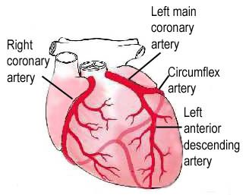
http://www.clevelandclinic.org/heartcenter/pub/guide/disease/cad/cad_arteries.htm

- The right coronary artery (RCA) perfuses, uh…the right side of the heart! See how the right side is actually on the bottom of the heart? Inferior territory: right ventricle.

The left side is twice as hard: two arteries! The big vessel there, the “left main”, divides into two:

- the left anterior descending (LAD):anterior LV territory.

- the circumflex (LCX): lateral LV territory.

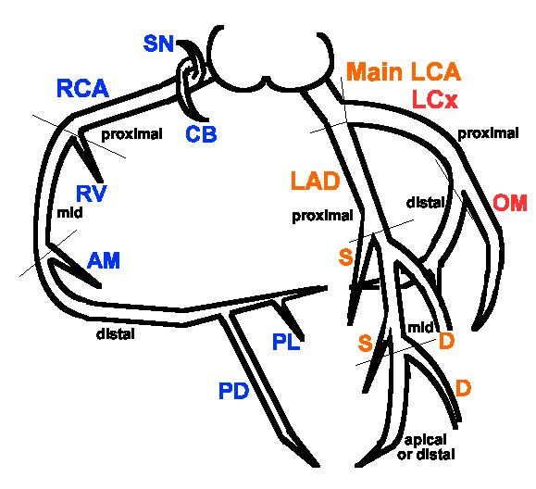

Here’s the same system of arteries, except schematic this time.

If you look at this for a minute, it starts to sort itself out: there are really only three main arteries in the system: RCA, LAD and LCX.

You need to see how the left main divides, where it says “Main LCA”: a plug there will produce ischemia or infarct in two places downstream. See that? Both the LAD and the LCX are threatened – at the same time - by a problem in the left main artery. Antero-lateral. Bad.

The same kind of thing can happen on the right side: a single occlusion can threaten the inferior territory (RCA), and the posterior one (PDA, or just PD in this diagram: “Posterior descending artery”, which perfuses the back of the heart. Infero-posterior. Also bad.

http://soback.kornet21.net/~heartist/coronary/cag-ori.gif

There are obviously more arteries, and they’re important too, but these three (or four) are the main ones. Knowing how they show up on a 12-lead will cover about 98% of the crucial territories that you’ll have to worry about at 4am when your patient is having chest pain. (You might be having chest pain too – last week a floor nurse who sent us her very sick patient went into an SVT…)

The key concept: as each artery perfuses a specific part of the heart, so each part of the heart has a group of leads on the EKG that reflects its activity.

The different groups of EKG leads only reflect what’s happening in their own part of the heart (most of the time – as usual, this is “with a lot of lies thrown in”.)

4-1: Inferior Territory/ Right Coronary Artery: Leads II, III, AVF

The heart lies sort of on its side in the chest, with the RV downwards, inferiorly. This territory is perfused by the right coronary artery. It’s worth mentioning that the inferior part of the heart is innervated partly by the same structures that innervate the stomach – the wall of the one organ lying near the other – and I understand that this is why people with inferior ischemia or infarct often have nausea or vomiting, or sometimes hiccups in place of anginal pain. (They call that an “anginal equivalent” – instead of having chest pain, they do something else.) An infarct here is an inferior MI: an “IMI”. Likewise, we say that a person with ischemia in the RCA is having “inferior ischemia”, which does not mean that it’s less important than any other kind!

Try to invent some useful memory device to help you remember the lead groups until they become more familiar. Remember “On Old Olympic Towering Tops…”, and all that? I understand that the really useful ones are usually dirty – anybody heard what the angry ER doc said to the abusive patient: “AMF, YOYO!”? Hey – I’m not telling what it means - but I understand that surgeons usually know that one…

4-2: Anterior Territory/ Left Anterior Descending: V2, V3, V4

The next time you do a 12-lead, look at where you’re putting the sticky precordial chest electrodes – they look at the front: the anterior part of the heart, really the septal and anterior parts of the left ventricle, which are (mostly) perfused by the left anterior descending artery.

See how it makes sense that V1 and V2
would be right over the cardiac septum?

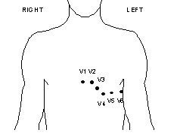
An And, this being the left side (says so, right there!), the LV going to get looked at by these leads:

Anterior LV (LAD): V2 (a little septal overlap, there,) V3, V4.

And here, all the way around (or you could say it in latin: “circumflex” – ha! Get it?) is the lateral LV territory, V5 and V6, (along with leads I and AVL.)

http://www.biopac.com/AppNotes/app172multiecg/chest.gif

Any EKG changes representing ischemia or MI should make you worry, but as they show up in different territories, they should make you worry about different things: these left-sided arteries supply the Big Pump, the LV – think about what interrupting it’s blood supply might do. Brrr! Infarcting LAD territory produces an anterior MI.

4-3: Lateral Territory: I, AVL, V5, V6

Look at where you stick V5 and V6 – all the way around the left side of the chest. Along with I and AVL, they reflect the lateral part of the left ventricle - also Big Pump territory. This part of the heart is perfused by the circumflex artery. So an infarct here produces what kind of MI?

If you were still awake several paragraphs up, you’ll recall that the left main artery divides into the LAD and the LCX, which between them perfuse most of the left ventricle. So if your patient infarcted there…the widowmaker. See that? Take another look at that diagram of the arteries – see how the left main supplies the two Big Pump arteries?

So: a left main artery occlusion will threaten both areas of the LV at the same time, and will produce an antero-lateral MI, with characteristic EKG changes in V2-4, as well as I,L, and/or V5-6. In a minute we’ll start looking at some 12-leads – one of them is for exactly this situation: both territories are being threatened.

Make sense? Any MI is a bad thing, but injury to the Big Pump is a very bad thing, and is responsible for cardiogenic shock. There’s lots more on cardiogenic shock and its treatment in the “PA-line” and “intra-aortic balloon pump” FAQs.

4-4: Septal Territory : V1, V2 (V2 overlaps sometimes: both septal and anterior areas)

These leads are right in the center of the chest, and look at the septum between the ventricles. As I recall, the septum is perfused partly by the RCA, and partly by the LAD. A septal MI would show in V1 and V2.

(I hear the CCU nurses yelling: “Hey! What about posterior reciprocity in the septal leads!?” Listen: don’t confuse the kids. This stuff is hard enough. We’ll work on reciprocity towards the end of the article, okay? Maybe.)

Starts to make sense when you look at it, doesn’t it? Give it time…

- What is the difference between coronary ischemia, and a myocardial infarction?

It’s surprising to me that people get mixed up about this. What do they teach the kids in nursing school, anyhow?

A brief rant needs to go here. (After 25 years, it appears on your license renewal: “permitted to rant.”)

A while back, we had a nursing student working with us as a tech – she was in her fifth year (fifth year out of a five-year BSN program!) – and she was hoping to work with us after school – new grad in the unit, that kind of thing. So by way of gentle encouragement, I pointed to the monitor where as I recall the patient was in something only moderately complicated - like, say, normal sinus rhythm, and I said: “So, Louella, what’s this rhythm that this patient is in here?”

Poor Louella, looking very sad, shook her head: “I don’t know.”

“Louella dear”, says I, not a little appalled, taken aback – I mean, five years is longer than med school, right? – “Louella, what exactly are they teaching you in that nursing school of yours?”.

“Um, a lot of theory?”

Ladies and gentlemen, here is a jewel. A student who looks the old, beat-up, battle-ax ICU nurse in the eye and says: “I don’t know.” A jewel! – because she understands the following essential point of ICU practice:

There are two - count ‘em - two correct answers to any question:

- The correct answer.
- “I don’t know.”

The second of these answers is equal in value to the first. It reflects honesty, the willingness to find out the answer, and the courage to admit ignorance when you feel that everyone else around you is so obviously smarter than you are. Our daughter #1, a brand-new RN, comes home every day holding her head: “Oh Goddess, (nurses pray to the Goddess of our profession, whose nickname is “Flo”), there’s so much I don’t know!”

Here is the beginning of wisdom. Any honest ICU nurse with experience will tell you, still holding her head: “The more you know, the more you realize you don’t know!” Truer words were never spoken…

Oh, and something else – don’t let all that “theory” get in the way when you need to know how to do CPR, or when to hold your patient’s digoxin, or why to argue that your patient is too unstable to go for their third MRI in three days, or why they might be on the wrong pressor, or why they need to stay in the ICU instead of being pushed out too soon, or…

Sigh.

Okay. Onwards. Where were we?

Ischemia vs. infarct:

It really is very simple: the difference between a blood vessel that’s still open – even a little – and one that isn’t open at all.

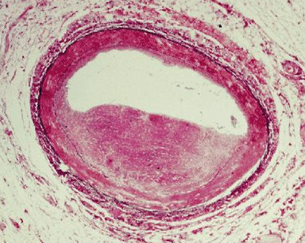

Here’s the lumen (the “tube”) of a coronary artery, which has been reduced to about half it’s normal width by the development of a big ugly red plaque thing, in the lower part of the picture. Usually the plaques occur in one spot along the lumen or another, rather than all the way along the length of the artery, and so the plaque is called a “lesion” – which is said to be more or less “tight”. Tighter being more severe, probably producing more symptoms, and more dangerous…

Still open.

http://www.medscape.com/viewarticle/460224_7

The tight lesion reduces the flow of blood to whichever territory happens to be affected. So while enough blood might get through when this person was at rest, that might not be true if the patient got up and started carrying groceries upstairs from the garage. The heart starts working harder, calls for more blood, can’t get it, and responds with pain (and EKG changes.)

This is ischemia. (CCU nurses: what kind of ischemia is this? Why is this “better” than the other kind, and what’s the other kind called?) The lumen of the artery isn’t completely plugged, but there’s a mismatch that develops between the demand of the cardiac muscle, and the ability of the artery to supply the oxygenated blood that it wants – not enough gets through.

How about this one?


Uh-oh. Looks like there was a little bit of opening left, where the arrow is pointing, but it’s gone now. This vessel isn’t just narrowed, it’s plugged. So now the muscle tissue beyond it isn’t just getting less blood, it’s getting no blood at all, and unless something is done pretty quick, that muscle tissue is going to die. This is infarction. (Up here in New England we call this
an “infahction”, as in: “Yah, he took a wicked infahction, but not a shock.”)

Not open.

http://www.visualsunlimited.com/images/thumbnails/990/99082.jpg

Okay ICU nurses, what’s probably plugging up that last little bit of vessel lumen, and what should this patient be receiving by way of treatment?

- What does ischemia look like on a 12-lead?

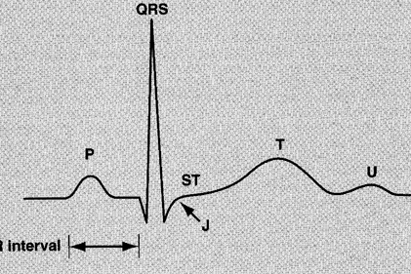
Remember the normal complex? Lead II – nice normal complex. Here’s the thing: ischemia and the stages of an MI are different processes, yes? So – they produce different kinds of changes in the normal complex of an EKG. The normal complex goes through a whole series of evolutions as it’s heart goes through an MI (look down a bit to see a quick chart of that.) But in ischemia, what you get is usually ST depression, below the isoelectric line:

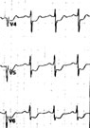
Not depressed.
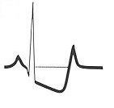
Way depressed.

Depressed.

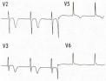
Or you could see
flipped T-waves:

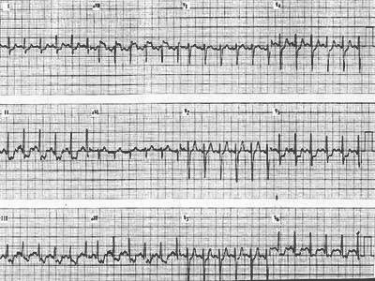

Here’s a pretty nice example of an ischemic EKG: so, what do we see?

ST depressions? Very good! Where?

II, yup – what goes with II? III, yup,depressions there too… and AVF. Nice! So this is ischemia, where in the heart? Which territory? Which artery?

Did I fool you? No? There’s ischemia in two other territories as well, isn’t there?

Ponder this one for a second: what do you think is meant by “rate-related ischemia”?

http://www.le.ac.uk/pathology/teach/CA/Cases/ecg_ischaemia.jpg

So: even before this patient goes off to the cath lab, which arteries do you think are going to show problems?
6-1- What do I do if my patient is having ischemia? What is “flashing”?

Your patient is short of breath with ischemia? (Which means which vessel/s are being ischemic? Producing what EKG changes, in which leads?) This is what is really meant by “flashing” – a point which is often confused with other acute shortness-of-breath scenarios. If the left coronary arteries (there, I gave it away) suddenly become ischemic, then the blood supply to the papillary muscles, and the chordae tendonae – remember them? – may drop off. So the chordae may stop working. So what’s the problem?

The problem is that the chordae are what make the valve leaflets work – so if they don’t work, then the valve goes flooey, and starts not to valve anymore. (You must not say “flooey” however – very low-class. You must say: “incompetent”, which comes from the original Latin, meaning, I believe, “flooey”.) Leaky. “Regurgitant”: with each systolic contraction, some of the blood is pumped backwards instead of forwards. If it happens on the left side, “mitral incompetence”, then blood being pumped backwards goes – where? Increasing the pressure in the what? Causing what to leak into the alveoli, filling them up? Very quickly?

Just like drowning. “Ischemic mitral regurgitation.” Sounds awful, and it is…

CCU nurses: how does this show up on a wedge pressure? How do you measure it?

Well – what to do? Everybody knows at least some of this by the time they get into the MICU: your patient is having chest pain, flashing maybe – what do you do?

One way to remember the moves to make is to think: “L,M,N,O,P”:

- Your patient is getting “wet” – give some Lasix. (Actually, lasix isn’t really what she needs, is it? Although it’s quite right to give – what she really needs is something to make that coronary artery dilate – what could you give that would make that happen?) If you’re really quick on the draw, sometimes you can head off intubation in someone who’s flashing – sometimes no matter how quick you are, you can’t.

- She’s probably having chest pain – give her some Morphine.

- What do you give everybody with cardiac ischemia? Under the tongue? Nitrates – IV nitroglycerine in the ICU. (That’s probably what the patient wants instead of lasix, right? But give the lasix too…)

- What does her heart tissue need more of? Administer some Oxygen. What if she’s a COPDer?

- Position her properly: sit her way up, high Fowler’s position, and put pillows under her arms to ease her work of breathing.

Now you want to see if her ischemia responds – this can be tricky if she doesn’t have classical, substernal chest pain – maybe her anginal equivalent is nausea, or shortness of breath. People with diabetic neuropathy who can’t feel their feet may not feel anginal pain either… But true cardiac ischemia should produce some kind of characteristic change in the EKG - you’re going to look for the ischemic changes to reverse – for the ST depressions to come back up, for the flipped T-waves to pop back up, in the same lead groups where they appeared at the beginning.

These maneuvers don’t repair the underlying problem though, right? – which is why people get cathed, and angioplastied, or stented, or bypassed.

But what if all that stuff doesn’t work? What if you do all that good stuff: L, M, N, O, P – and the patient is still ischemic? Now what? Maybe a trip to the cath lab? Maybe. It might, though, be time for the CCU nurse’s favorite toy…

Begins with “I”, ends with “P”…?

CCU nurses: What is “pseudo-normalization”, and what’s it got to do with ischemia?

(Is pseudo-normalization what really weird people do, but only on Halloween?)

(I actually thought that one was pretty good, myself!)

- What are the stages of an MI, and what do they look like on a 12-lead EKG?

This time the problem is different: the muscle tissue beyond that little plug is not just inadequately supplied – it’s not supplied. Going to die. I hate it when that happens!

The underlying process took a surpisingly long time to clarify, but finally in the 1980’s they figured out that little clots were the culprits in causing MIs, suddenly occluding what was left of a tight arterial lumen already almost blocked by plaque. The ‘tight lesions’ are the places along the lumen of the coronary artery where the cholesterol plaques have nearly – but not completely – closed the lumen to blood flow. As I understand it the theory says that platelets, loving as they do to stick to rough places, tend to form clots that plug what small opening is left – which is what lies behind the whole concept of ‘clot-busting’.

Apparently there’s a whole inflammatory aspect to the process of infarction as well, involving the plaques rupturing, which doesn’t sound healthy at all. Also there’s a story around that bacteria from the mouth may be involved in plaque formation, and that flossing can help prevent it. Just something else grandma was right about.

There are several phases that an MI “evolves” through, and each phase has its own clear EKG characteristics.

Before we go through each bit in detail, here’s a quick look at the whole process.

Time Passing This way…
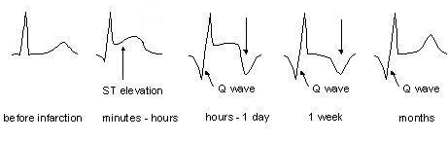
http://heartkorea.com/ecg_guide/ecg_04_2.htm

7-1- First Stage: Acute Injury (ST Elevations):

Let’s make sure that we know what we’re looking at here, exactly:
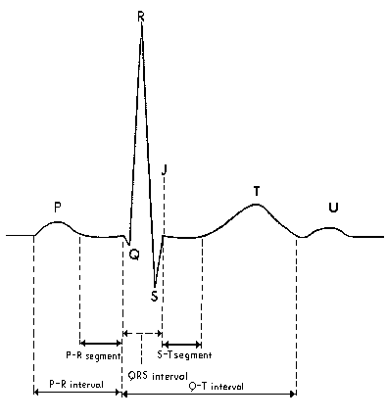

Take a look at the QRS complex, in the middle of the diagram. You need to know exactly which wave is which. Again, it’s not too hard:

The arrow on the left is pointing at the R-wave, which rises up from the isoelectric line, which is this one,

here. The flat part.

The upper right-hand arrow is pointing to the S-wave, which slides back down.

www.bilgi.umedia.org.tr/ yayin/tejm/ekg.htm

The lower right-hand arrow is pointing to the ST segment – the same part that became depressed back in question 6.

So - now that there’s a clot occluding the lumen, the process of infarction begins. It turns out that there are three clear stages in the progression of the MI – the first is the period of the ‘acute injury’. This stage lasts some hours - I remember being taught that it’s roughly six - and represents the period of time between the acute blockage of the lumen, and the start of tissue death in the part of the heart that is distal to that plug. On an EKG, this stage of infarct will show as ST elevation in all the leads that reflect whichever part of the heart is being affected.

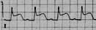
See how the S-wave doesn’t go all the way back down, and is holding the T-wave up with it? S-T elevation. Early-stage, acute injury MI. Bad.

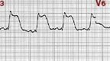
These are really elevated! “Tombstones”…

Very important: This six-ish hour period is the time when you want to try and get your TPA up and running – if you wait any longer, it may be too late to salvage the muscle tissue.

Just as important: what if the patient had had a CVA six months ago?

7- 2- Second Stage: Necrosis (Q-waves):

Up.
Here’s the normal complex again. Take a look at the QRS complex. Is there really a Q-wave here? Until they get to the ICU, lots of nurses never even see a Q-wave, and so don’t really know where they should be?

Sort of, kind of, maybe, that little tiny wave there at the end of the PR interval – see it? That little thing, says “Q”? Not much of a wave...a “non-pathologic” q-wave.

The idea is that normally, ignoring that wee little Q, the first move that a QRS complex makes after the PR interval is to go – which way? Who said “Up!”? Yes, correct. Up is right. See that? Up, after the PR?

Big q-waves represent the progression of the MI from the stage of acute injury to the stage of necrosis. Brrr! They show up as the QRS moving downwards first, after the PR interval.

Take a look at this normal 12-lead. In every lead except AVR – we’ll leave AVR out of this, since it doesn’t fall in any of the lead groups, and in fact I don’t really know what it’s for – in every lead, after the PR inteval, the QRS goes up. Can you see that, all those movements up?

All those arrows: upward QRS’s. What about this one?

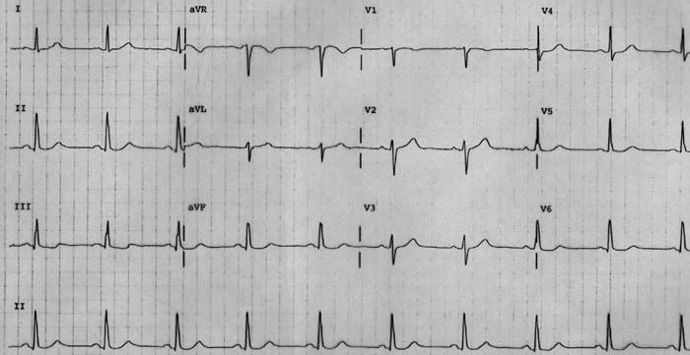

http://www-personal.umich.edu/~danielbc/2004/study/normal%20EKG.jpg

What about V1? Looks like a big q-wave: a downward movement after the PR. But see – is it the only one there is? V1 goes with which other lead? (V2.) Is there a q-wave there as well? (No.)

This is important: if you’re going to see some kind of change in a 12-lead EKG, you should clearly see it in all the leads of a group, or it may not really mean anything – artifact maybe, or iffy lead placement. My own EKG has a consistent q-wave in lead III – but not in II or AVF. My little pet q-wave – it just lives there…

Here’s another one. See the PR interval? What does this QRS do – go up first, or down first? Down is correct. This is definitely a “pathologic” q-wave: greater than a third of the total size of the QRS. This one is the whole size of the QRS!

The appearance of q-waves means that the patient has missed the time “window” for clot lysis – which makes sense, considering that the artery has now been plugged for more than four to six hours. Not much tissue can survive without blood that long. You figure – cardiac tissue must be really tough stuff – how long does it take before irreversible brain damage occurs in an untreated, hypotensive arrythmia? Six minutes? Mine’s probably even less…

Here’s an interesting strip, below.

See the ST elevations, and the Q’s, all at the same time? This person is evolving from the first stage to the second – moving from the stage of acute injury to the stage of necrosis. The ST segments will come back down to the baseline (the “isoelectric” line) as the Q’s develop.

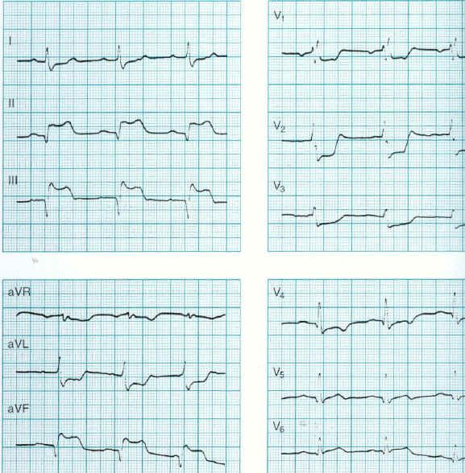

ST elevations, sliding back downwards as the Q waves grow…

7-3- Third Stage: Resolution (Persistent Q’s, or flipped T’s):

The resolution stage represents the development of scar tissue in the infarcted area, which happens roughly two weeks after the necrotic stage of the MI. The affected part of the heart will still show EKG changes, possibly forever – either what are called ‘persistent Q-waves’, or flipped T-waves. Unless he’s having ischemia again!

A lot of the interpretation depends on context. If an elderly gentleman – say, myself (!), came in with a broken ankle, and you saw Q’s, or flipped T’s the routine EKG that you do on every older person, you’d cleverly ask me: “Uh, Nurse Markie, did you have an IMI in the past at some time?” You would probably say that the Q’s or T’s represented an old MI, rather than one I was in the middle of.

Unless I was having chest pain…

Here’s another look at the whole process. Any clearer now?

Before the MI 1st Stage Necrosis Resolution: the Q’s remain, and maybe
flipped T as well… or not.
Let’s say it again: remember that these evolutionary changes will stay in the same group of leads the whole time, reflecting the events in the part of the heart that they represent.

7-4- What do I do if my patient is having an MI?

In two paragraphs? Did you leave your copy of Braunwald at home?

Well – timing is everything. Is the patient in stage 1? – time to think about the cath lab, or TPA, unless there’s some really good reason not to give it. Which there may be…

If your patient does get TPA, look for the ST elevations to come back down to baseline without the development of q-waves.

Stage 2? Too late – the patient is going to have to “take her hit”. Watch out for the usual stuff: ectopy, changes in rhythm, blood pressure, all that.

Remember that different kinds of MIs present in different ways: for example, inferior MIs often affect the conduction system: they may “brady down”, buy atropine or external pacing pads (ow!), or a temporary pacing wire – neat stuff like that. They may get the hiccups, or nausea and vomiting instead of having chest pain, as the inferior cardiac nerves also innervate the top of the stomach, so I’m told.

Anterior, lateral, antero-lateral MIs – Big Pump Mis: they can get into all sorts of nasty trouble: cardiogenic shock, maybe. Big “flash” events, for another. Make sure that the specs for cardiac markers get sent every – what is it now, still every eight hours? Troponin, maybe still CK and MB isoenzymes – and I think they still have us do EKGs with every set. Take a look! Watch for evolution, all that good stuff!

- What is “electrical reciprocity”?

“You mean there’s more?” (sigh)…there’s always more! Why do you think they write those enormous books and all?

This is a fairly important concept, and it does have to go into this article, but in the swirl of ST elevations, depressions, mountains, valleys, rivers, plagues of frogs…you might want to put this bit off until later. It’s a lot to soak up at once.

I hate reciprocity – it’s very confusing. Describing reciprocity is like describing how you can look at something through binoculars: if you look one way, the image is right side up – but if you flip the binoculars and look through the wrong end, the image is upside down, even though you’re still looking at the same thing. Some EKG lead groups act this way – they “mirror each other” electrically, so that ST elevations in one group will show up as ST depressions in the other. Not ischemia – “mirroring”. You may need to reflect on that for a while…

There are only two main areas of the heart that do this: the inferior and lateral ones; the septal and posterior ones. A set of inferior ST elevations in II, III and AVF can produce lateral ST depressions in I, AVL, V5 and V6. You’d think that this would mean lateral ischemia, but no – it’s a reflection, bouncing electrically across the heart from the inferior injury, showing up in reverse.

Yup, it’s confusing. The trick is to remember that when assessing EKG changes, ST elevations always come first – ahead of anything else on an EKG. If there are ST elevations anywhere on an EKG, you should wonder if any ST depressions on the same EKG might be reciprocral, instead of ischemic. See if they fit: inferior-lateral? If there are no ST elevations, go with ischemia as your interpretation.

Inferior MI, lateral reciprocity.

Here’s a pretty good example: see the inferior ST elevations? So that’s going to be the primary process.

Now - see the ST depressions in I, and AVL? Lateral leads? That’s not ischemia – it’s the “mirrored reflection”of the inferior MI. Question for the cardiologist – why isn’t there reciprocity in V5 and V6?

There’s more here, though.

See the ST depressions in V1 and V2? Read on, we’ll talk about posterior reciprocity, and why it makes sense that it would show up in this situation. But ST depressions show in V3 and V4 – too many changes for me. Call cards!

http://heartkorea.com/ecg_guide/ecg_04_2.htm

Lateral MI, inferior reciprocity.

See the ST elevations, this time in I and AVL? They’re subtle, but they’re there. Again, for some reason the entire lead groups isn’t represented, but enough of it is, and in the right way, to be convincing – the primary process is a lateral MI.

So let’s get reciprocal: what’s happening in the inferior leads? Not ischemia.

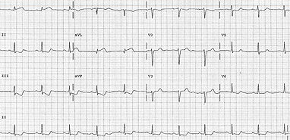

www.medscape.com/viewarticle/450583

Posterior reciprocity is even more terrifying and complicated. If you don’t like horror movies, don’t read this part – it’s just too awful.

The septal leads (they look at the front of the heart) will reflect a posterior event (which is in the back) in the same way that the inferior/lateral ones do, but it’s even more ridiculously tricky, since reading the posterior leads is made sort of difficult by the fact that…well… there aren’t any posterior leads! (At least not on a normal 12-lead.) Sheesh!

See - on a 12-lead - the way you look at the back of the heart, is by looking at the leads that look at the front of the heart, only backwards. And upside down. Don’t hurt your neck. Remember the binoculars? If you reverse them, then the image is upside down and backwards?

So: here are a couple of sets of septal leads: V1 and V2.
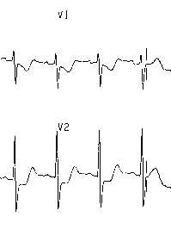
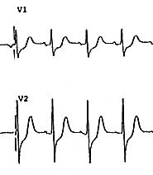

ST depressions.

Now – here are the same groups of leads, flipped and reversed:
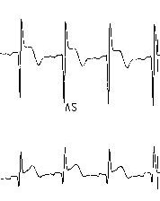
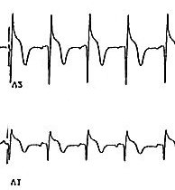

ST elevations!

See the ST elevations? This is what you would see if you put real posterior leads on the patient. Posterior MI – in fact, you’ll see MDs do just this with an EKG – they’ll flip it over and hold it up to the light, looking for just this effect.

Sometimes the clue is: is the patient having an inferior MI? Remember that the RCA perfuses both the inferior and posterior areas – is there ST elevation in II, III and AVF? And ST depression in V1 and V2? Those septal leads may be giving you a “mirror” of an infarct process, rather than showing ischemia – an infero-posterior MI.


Uh-oh – Jayne’s here: “Did you tell them about the posterior leads?”
The Preceptor: “What posterior leads?”
J: “You’re telling me that you don’t know how to do posterior leads?”
The P: “There are posterior leads?”
J: “Of course there are posterior leads, you… listen. Dopey. You take three more electrode stickers, and you stick ‘em on the patient’s chest, going around towards the right, continuing the right-sided chest leads. You told ‘em about the right sided chest leads, didn’t you?”
About…1986? The P: “Well, um no, not yet…”
J: “Well then tell them, you enormous goof!”
http://www.icufaqs.org/jayneandbabyben.jpg

Just like an old married couple… cute baby, huh? We were all a lot cuter back then…He’s taller than I am now, and doing all that great 18-year-old stuff…dreadlocks, last summer. I thought about them myself for a minute, until somebody reminded me about the bald spot…I mean, I can’t see it, can I? And there’s still some hair in the front… so on the principle of anterior reciprocity, does this mean that I can pretend that the bald spot isn’t there if I want to?

Daughter #1 weighs in: “No, you can not have dreadlocks with a bald spot. That’s almost as bad as an old hippie with a bald spot and a ponytail. Eww!”

Well. You should’ve seen my hair when I was 17 – down the middle of my back, flew in the wind when I would cycle around Central Park in the summer of ‘72…nope, no helmets back then. “Moondance” on the radio. Had Dwayne Allman died? Janis and Jimi were gone…ten years after that, daughter #1 was born. And now she’s a nurse. And now I’m “The Man”. Sigh…but my son and I found a 1972 Honda, little motorcycle, fixed it up…but I don’t take it faster than 30!

What does this have to do with the heart? Everything, man!

8-1: What is a right-ventricular MI, and why is it going in the section about reciprocity?

Well – it’s going here because I was going to leave it out… let’s see if I can remember this. Posterior events go along with inferior ones, because the back of the heart is perfused by the posterior descending artery (PDA), which branches off of the right coronary artery (RCA).

This is the same kind of process as a left main infarct: two areas can be affected at once. Both the inferior and posterior territories will by affected by a single plug in the RCA, producing an infero-posterior MI.

A plug here…

produces an inferior infarct here,

and a posterior infarct here.

Here’s the PDA.

http://soback.kornet21.net/~heartist/coronary/cag-ori.gif

Now go back and look at the EKG on page 17. Infero-posterior, you think? Plus some anterior ischemia? Eww!

Infarcting all this territory can produce yet another kind of MI, the “right ventricular” MI/ RVMI. Jayne says that up to 50% of all inferior MIs affect enough RV territory to “stun” them into “hypokinetic inactivity” – meaning “they don’t move much, and don’t pump much.” To see this on an EKG, you need to do a 12-lead with the chest leads applied backwards – going around towards the right, instead of towards the left. “Ralph - do a right-sided EKG, will you?”

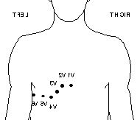
Something’s not right – it looks familiar, though…

I couldn’t find an image of right sided leads…but this is the basic idea. The placement is the same as usual, except going in the other direction.

Jayne says that to do true posterior leads, here’s what you do: take all the chest lead wires off.

Now stick on three more chest electrodes along the same line of V5 and V6, along the fifth intercostal space, using the same spacing that you used for the chest leads, ending up under the scapula: V7, V8, and V9.

Now start reattaching the wires: put the V1 lead wire on the V4 electrode. See? The V2 lead goes on the V5 electrode. And so on around the chest. Now when you do your 12-lead, you’ll get a clear picture of what the entire RV is doing: inferiorly and posteriorly.

No – don’t ask me what it should look like!

8-2- How are RVMIs managed?

RVMIs are a different kind of beast entirely from the left-sided kind. By definition, a left-sided MI involves the Big Pump – and your patient is going to get into fluid-management problems, CHF, that sort of thing, right? High wedge pressures, because the LV can’t empty itself? Lasix, fluid restriction, hypoxia…

In a right-ventricular MI, the idea is that the ventricle becomes hypokinetic (“It doesn’t move much.”) – just sort of sits there, stunned, instead of sending blood along to the lungs. So what?

So: if the blood doesn’t get pumped along to the lungs, then how is it going to get through those lungs and over to the other side, so that it can get pumped out into the arteries, which is after all how you make a blood pressure? The LV needs a steady supply to work with – instead of being suddenly injured and overloaded, it suddenly doesn’t have enough volume coming in. “Preload”.

These people get lots of volume, to flood that sluggish RV and keep the blood moving along to the lungs – just the opposite of a left-system MI. Lots and lots of fluid – liters and liters. Ten in a day, maybe. Maybe more. Give them normal saline – isotonic; stays in the vasculature…

Well. I did warn you about the posterior stuff…look, I know, it’s hard. And maybe I lied a little about how hard it really was. Maybe a lot. But aren’t you learning all kinds of cool stuff? Soak up what you can, then forget about it for a year – then come back and read this again, and see if more of it clicks.

9- Going through the evolving EKGs of an MI.

Okay – ready to look at EKGs all the way through an MI, all three stages? Let’s go.

9-1- Acute Injury - Stage 1

Look at the ST elevations in leads II, III and AVF in this first EKG – pretty impressive. They’re not quite high enough to be called “tombstones”, but they’re impressive.

Important question: what kind of MI is this? Which territory is being affected? Anterior? Inferior? Lateral? Septal? Yukon?

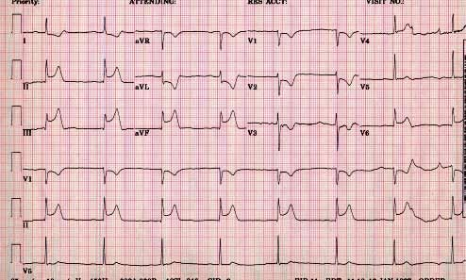

Take another look at those ST elevations. Has the patient “Q’d out” yet? Is it too late for clot lysis, you think, or is there still time?

I think we also see some reciprocity: see the ST depressions in I and AVL? That would be lateral territory, which is reciprocal to, or reflective of what area? Inferior – correct. So what kind of MI is this? See that? The reciprocity doesn’t show in the whole lateral lead group though, does it? Happens that way sometimes – but certainly there’s a nasty primary process going on in II, III and AVF.

How about the septal leads?

Which coronary artery is being affected? What about the PDA?

What kinds of specific bad things do these people do? What might you specifically want to have on hand? (Take a look at 7-4 again.)

9-2- Necrosis - Stage 2:

How about now? Not the same patient - same kind of MI though, same territory. But now things are looking a little different down there in II, III and AVF. See how the Q-waves are starting to show up?

Not just starting! This person is in the process of “Q-ing out” inferiorly. “Can we lyse this guy?” “No – look, he’s q-ing out.”

Are there other interesting changes to find on this EKG? What territories do they represent?

http://www.ekgreading.com/EKG3-3.jpg

I think there’s some interesting reciprocity happening here: remember, ST elevations always come first in interpretation. “So: if the ST elevations are inferior, and inferior is reciprocal to lateral, then…oh, my head hurts!”

No – keep going, you were doing great! The inferior territory “reflects” the lateral one. So the ST elevations in the one show up as ST depressions in the other. Sure enough: I is a little depressed, AVL is definitely depressed, but once again I think V5 and V6 are sitting this one out.

How about the ST depressions in V1 and V2? Could be septal ischemia…hmm -I think this is even yet another inferior-posterior MI. This person’s primary process is an IMI, right? Remember the diagram: the RCA perfuses the back of the heart…I think those ST depressions are “mirrored” – they’re “reflecting” an ST elevation process going on, way in back there.

And what’s going on with V3 and V4? Uh – would somebody please call the cardiologist?

9-3- Resolution - Stage 3

Well, clearly these aren’t all from the same patient. For one thing, the rhythm is different – what rhythm is this? In this “post-MI” EKG, try to find the “persistent” Q-waves in II, III, and AVF.

But the idea is pretty well conveyed, I think, isn’t it? Evolution of an inferior MI from the acute stage, to necrosis, to resolution?

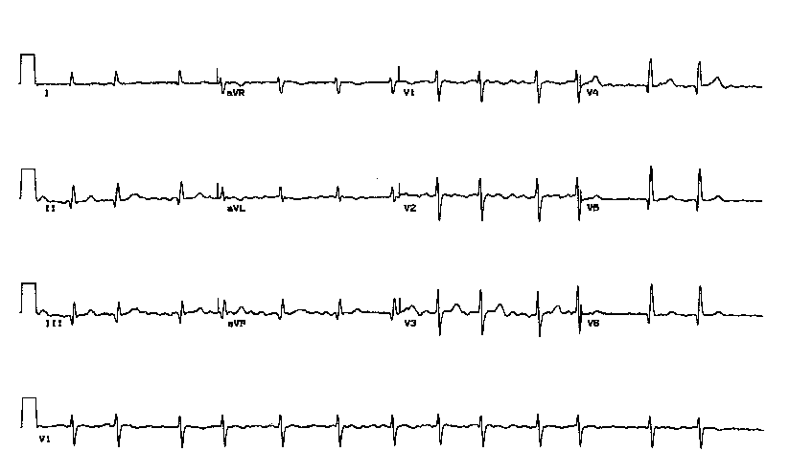
Do you see Q’s anywhere else here? Are they large enough to worry you?

Whew! Reading EKGs takes it out of you, doesn’t it? Can we go out for mimosas now?

10- Another one.

Ready to try another one? You sure? You want a sublingual nitro? Me first, I’m the old one…

What’s going on this time? Whoa – all kinds of neat badness!

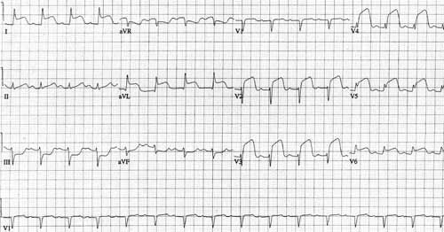

http://members.evansville.net/ict/ekg-ami-antlat.htm

Okay - let’sbe systematic:

Lead I shows ST elevation, so there’s an acute MI going on. Lead I goes with AVL, V5 and V6: ST elevations throughout the lateral territory. Oooh: a circumflex infarct, right?

After starting with lead I, go on to lead II: anything there? Small QRS…how about the rest of the group: III and AVF? ST depressions in III for sure, maybe just a little in AVF. Hmm – lateral ST elevation, inferior ST depression…

Wait a sec – didn’t we say a while back that ST elevations always come first in interpretation? So ST elevations laterally…and infarct is always interpreted as the main process…ha! Inferior reciprocity!

Onwards. Where were we? We did lateral, we did inferior, what’s left? The chest leads – ok, start with V1. Yow, a q-wave! And it gets worse from there – V2, V3, V4 – big anterior ST elevations that are already starting to form q’s…another infarct area!

So there are two areas with ST elevations: the lateral group, and the anterior group. That would mean infarct in the circumflex and the LAD…wait a minute…uh-oh – this guy is infarcting a left main lesion!

Excellent!

- What are intervals all about?

Remember these? People memorize these, spit them out on quizzes, but sometimes they don’t get the real idea. What is an interval, actually?

It’s a length of time -how long it takes for something to go from one place to another.

So – what is it that’s doing the going? What’s moving?

It’s the signal – the signal actually moves along the conduction pathways. It would probably look something like an ocean wave – if you were standing somewhere along the pathway, and slowed everything down so that you could watch carefully, you’d probably see the wave coming along at you as it moved along the path. Or you could surf that wave and watch as you passed by the cardiac anatomy.

This first arrow on the left shows the signal as it generates the p-wave – the p-r interval.

The second arrow shows the movement of the signal through the ventricles: the QRS. Which one moves faster?

Who remembers what the T-wave is?

Intervals can be too long, or too short. Makes sense. Let’s take them one at a a time:

-PR interval: Too long? Greater than .20 seconds? First degree heart block?
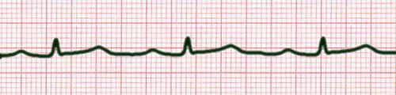

http://www.anaesthetist.com/icu/organs/heart/ecg/images/e_longpr.jpg

First degree heart block, right? Probably because the conduction system has taken some kind of hit: ischemia, or an infarct, the signal isn’t travelling through the atrial tissue at the normal speed.

Too short? What’s your patient’s heart rate? In the 40’s? Why am I asking?

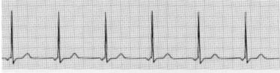

http://www.medceu.com/images/sample19.jpg

That is short. The rate’s not that slow…still, this is probably coming from the AV node. Junctional tachycardia: a faster-than-normal junctional rhythm, with the p-waves going backwards along their normal pathway through the atria. Take a look at the FAQ on arrhythmias for more info on that kind of thing…

- QRS interval:

Now that I think of it, I don’t think I’ve ever heard anyone complain about a QRS interval being too short. Other things, maybe…

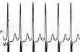
Jayne points out that QRS’s are very short in SVTs…

http://www.amc.edu/amr/current/EKG02md.jpg

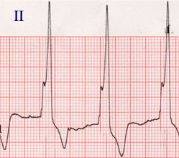
This is more what you tend to see. Too long: greater than .12 seconds…probably one of the bundle branches is blocked.

I think the bundle-branch-blocks are going to have to get an article of their own one of these days – mostly because I don’t know how to tell the one from the other, myself…

http://www.med.nus.edu.sg/paed/medical_education/cardiac_thumbnail/investigations/ecg.htm

- QT interval:

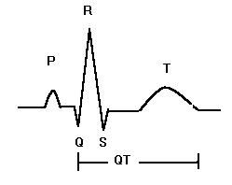
This is the one that a lot of people get worried about in the ICU, usually because it’s getting longer than it ought to be. Remember that the QRS is the time it takes for the signal to depolarize the ventricles? And the t-wave is the time it takes for the conduction system to reset? So: the QT interval is the time it takes to do both of those.

http://www.fbr.org/swksweb/ecg_long.JPG

Apparently it can be too short:
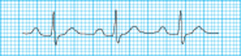
Looks okay to me – the website said this “short QT interval strip” was supposed to indicate that someone’s calcium was too high. I think they got this one wrong – long PR interval, maybe?

http://www.studentbmj.com/back_issues/0903/education/314.html

Too long is what they don’t like to see:
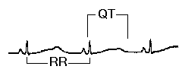

Looks long to me. Dangerous. The heart is taking too long to re-polarize – nasty arrhythmias such as Torsades can result. Haldol is famous for (occasionally) provoking this.

http://www.ecglibrary.com/ecgs/l_qtfig.gif

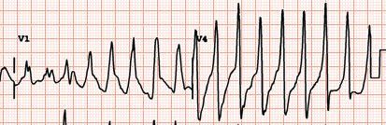
Yup – that’s it! If you hang around the ICU long enough, giving haldol now and then, you will definitely come across this one…grab the magnesium.

http://www.lfhk.cuni.cz/farmakol/anglicka/hughes/html/QTinterval/HTML/ekg-QT.gif

I seem to remember that this is also why cisapride and – what was that antihistamine that everybody used to take? - Seldane – were both taken off the market.

I’m pretty sure that we used to measure the QT intervals when we were loading patients with oral quinidine – but now as I come to think of it, I hardly remember doing that in recent years. Nor do I remember much else, unfortunately…

Here’s the thing: the QT gets shorter as the heart rate speeds up, and longer as it slows down. So what you really need to know is: is the QT interval too long - at all? Regardless of the heart rate - fast or slow? So the thing to do is to calculate the QT interval with the heart rate factored in, and indeed, this is called calculating the “corrected QT interval” – the “QTc”.

Happily, our monitoring equipment will actually do this for you – the thing to try to remember is that average of 380 – 400 milliseconds. Longer than 440 milliseconds is too long.

Take a look at the strips on the slide from the website link that appears below. If you got out your calipers and measured the intervals, you’d see that the QT interval is longer at the slower rate, shorter at the faster one. But the ratio of lengths probably stays the same, regardless of the rate. Too long is too long. Dangerous.

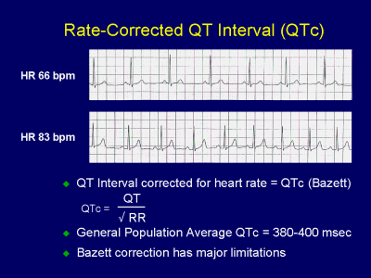

http://www.fda.gov/OHRMS/DOCKETS/AC/01/slides/3746s_01_Ruskin/sld021.htm

12- What does a 12-lead EKG look like if a patient’s potassium is too high? Too low?

Potassium is the main electrolyte that we see causing EKG disturbances in the MICU.

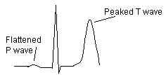
Hyperkalemia. A really high potassium – say, greater than 6.0 – is an unhappy and dangerous thing. You’ll certainly be treating that – but the development of the peaked t-waves is what really sets off concern, probably indicating the development of myocardial toxicity.

How would you anticipate treating this?

http://www.superscore.com/HyperK1.jpg

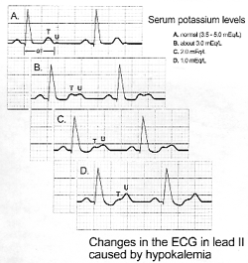

This chart is a little hard to read – this is going the other way: hypokalemia, getting worse from the top strip downwards. See how the U-wave develops? What’s this patient’s creatinine, and why do we care?

Cardiologist goes into a bar, sees a cute EP fellow sitting alone: “Hey, nice waves U’ve got…”

(Hey! No hitting the preceptor!)

http://www.ascp.com/public/pubs/tcp/1997/pics/heart5.gif

